**DAILY ONLINE ACTIVITIES SUMMARY**

|  |  |  |  |  |  |  |  |  |
| --- | --- | --- | --- | --- | --- | --- | --- | --- |
| **Date:** | 10-06-2020 | | | | | **Name:** | K S Prajwal | |
| **Sem & Sec** | IV A sec | | | | | **USN:** | 4AL18CS032 | |
| **Online Test Summary** | | | | | | | | |
| **Subject** | | Object oriented Concepts | | | | | | |
| **Max. Marks** | | 30 | | **Score** | | | 16 | |
| **Certification Course Summary** | | | | | | | | |
| **Course** | Face Recognition with Deep Learning using Python | | | | | | | |
| **Certificate Provider** | | | Udemy | | **Duration** | | | **3 hr** |
| **Coding Challenges** | | | | | | | | |
| **Problem Statement:**  1: write a C++ program to rotate a matrix k times | | | | | | | | |
| **Status:** completed | | | | | | | | |
| **Uploaded the report in Github** | | | | | yes | | | |
| **If yes Repository name** | | | | | <https://github.com/alvas-education-foundation/KS_Prajwal> | | | |
| **Uploaded the report in slack** | | | | | yes | | | |

Online Test Details: (Attach the snapshot and briefly write the report for the same)

Certification Course Details: (Attach the snapshot and briefly write the report for the same)

Coding Challenges Details: (Attach the snapshot and briefly write the report for the same)

**Online Test Details:** The online test was from modules 3 and 4, all the questions were objective type questions. All questions were optimal and were easy. The score that I got was 20/30

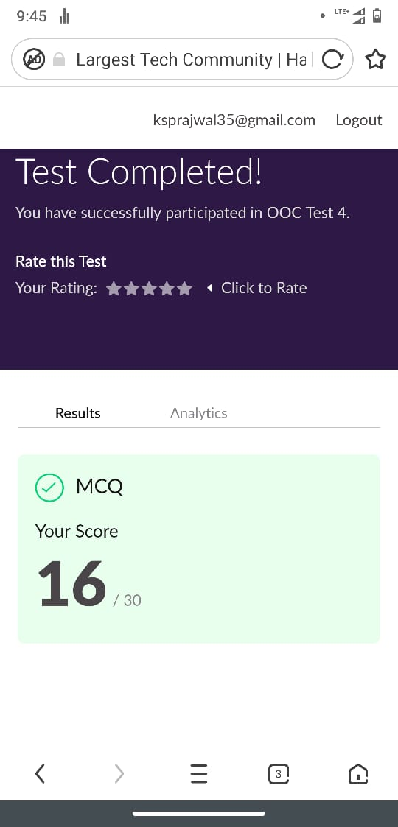

Snapshot of certification course:

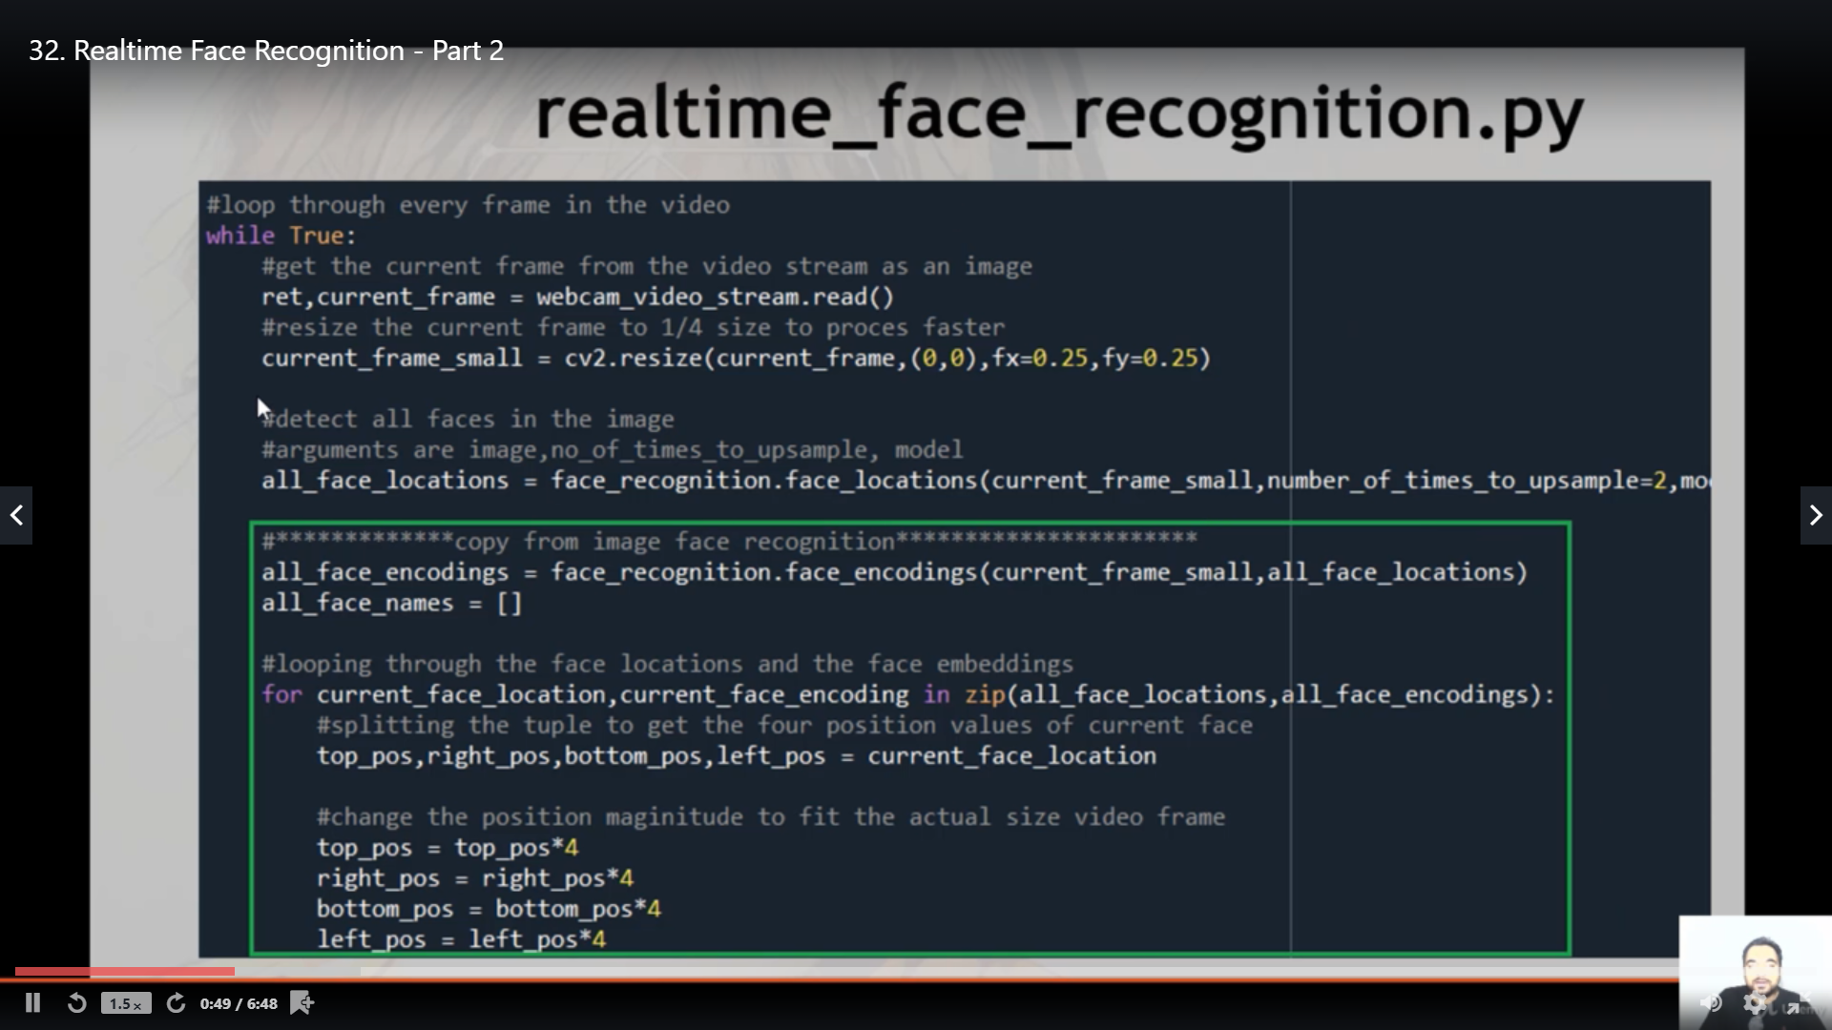

It was about the facial recognition using python in todays section they showed the demo on real time face detection and multiple face detection

**Online coding:**

Problem 1: (using C++) write a C++ program to rotate a matrix k times